|  |
| --- |
| HCC2, HCCE2, BSHC2, BSHCE2, BSHBIS2, BSHBISE2 |
| Requirements Specification (RS) |
| [Type the document subtitle] |

|  |
| --- |
| insert all student names  [Pick the date] |

Requirements Specification (RS)

Document Control

Revision History

|  |  |  |  |  |  |
| --- | --- | --- | --- | --- | --- |
| **Date** | **Version** | **Scope of Activity** | **Prepared** | **Reviewed** | **Approved** |
| 14/10/2005 | 1 | Create | AB | X | X |
| 21/10/05 | 2 | Update | CD |  |  |

Distribution List

|  |  |  |
| --- | --- | --- |
| **Name** | **Title** | **Version** |
| Arghir Moldovan | Lecturer |  |
| Eamon Nolan | Lecturer |  |
|  |  |  |
|  |  |  |
|  |  |  |

Related Documents

|  |  |
| --- | --- |
| **Title** | **Comments** |
| Title of Use Case Model |  |
| Title of Use Case Description |  |

**Table of Contents**

1 Introduction 4

1.1 Purpose 4

1.2 Project Scope 4

1.3 Definitions, Acronyms, and Abbreviations 4

2 User Requirements Definition 4

3 Requirements Specification 4

3.1 Functional requirements 4

3.1.1 Use Case Diagram 5

3.1.2 Requirement 1 <name of requirement in a few words> 5

3.1.3 Requirement 2 <name of requirement in a few words> 6

3.2 Non-Functional Requirements 7

3.2.1 Performance/Response time requirement 8

3.2.2 Availability requirement 8

3.2.3 Recover requirement 8

3.2.4 Robustness requirement 8

3.2.5 Security requirement 8

3.2.6 Reliability requirement 8

3.2.7 Maintainability requirement 8

3.2.8 Portability requirement 8

3.2.9 Extendibility requirement 8

3.2.10 Reusability requirement 8

3.2.11 Resource utilization requirement 8

4 GUI 8

5 System Architecture 8

6 System evolution 8

# Introduction

## Purpose

The purpose of this document is to set out the requirements for the development of ……………

The intended customers are ……….

## Project Scope

The scope of the project is to develop a …………….The system shall have a ……………

John Smyth was involved in discussions with John Ryan from AN Company Ltd. To elicit the following requirements

This section also details any constraints that were placed upon the requirements elicitation process, such as schedules, costs, or the software engineering environment used to develop requirements.

## Definitions, Acronyms, and Abbreviations

AD Another Definition

……..

# User Requirements Definition

The Customers are people who need to buy a tool that will help teach them step by step how to improve their environment for the production audio.

The Most of YouTube's will work in situations that they will need to control for external noise, they can be given how to instructions in how to easily and cheaply improving the sound quality and use our app to find the absorption for Chroma screen (green screen) as an example, which is important to CGI (Computer-Generated Imagery) environments, which a lot of up-to-date YouTube's use for their videos.

The Home Artists will use our app to acquaint themselves with how to change a room in their house for a perfect acoustic quality of a live audience or even for recordings of their music or other audio sources.

The DJ's work in many locations, from clubs and pubs to house parties, they need a way to control the sound behavior from any place in the room, on time and our app can make the difference.

The Event Organizers will have 101 things to do one of the most important things, when they are organizing a place that will have a lot of people in it (like a conference, concert, wedding reception), is to make sure the right people can be heard at the right time and our app will show them where they can put the speaker for best effect.

The App has a multipurpose design, it easy to use, uses a minimum of space and will have a calculation and recording audio capabilities specifies it to the user's location of use.

# Requirements Specification

All requirements should be verifiable. For example, experienced controllers shall be able to use all the system functions after a total of two hours training. After this training, the average number of errors made by experienced users shall not exceed two per day.

## Functional requirements

This section lists the functional requirements in **ranked order**. Functional requirements describe the possible effects of a software system, in other words, what the system must accomplish. Other kinds of requirements (such as interface requirements, performance requirements, or reliability requirements) describe how the system accomplishes its functional requirements. Each functional requirement should be specified in a format similar to the following:

Short, imperative sentence stating highest ranked functional requirement.

### Use Case Diagram

Each requirement should be uniquely identified with a sequence number or a meaningful tag of some kind.

The Use Case Diagram provides an overview of all functional requirements.

### Requirement 1 <name of requirement in a few words>

The heading of this section should read, e.g., “Requirement 1: User registration” or “Requirements 1: Participant takes test”

#### Description & Priority

A description of the requirement and its priority. Describes how essential this requirement is to the overall system.

#### Use Case

Each requirement should be uniquely identified with a sequence number or a meaningful tag of some kind.

**Scope**

The scope of this use case is to …….

**Description**

This use case describes the ………..

**Flow Description**

**Precondition**

The system is in initialisation mode……..

**Activation**

This use case starts when an <Actor>…………

**Main flow**

1. The system identifies the ………….
2. The <Actor> …………...(See A1)
3. The system …………..(See E1)
4. The <Actor> ………….

**Alternate flow**

A1 : <title of A1>

1. The system …………..
2. The <Actor> ………….
3. The use case continues at position 3 of the main flow

**Exceptional flow**

E1 : <title of E1>

1. The system …………..
2. The <Actor> ………….
3. The use case continues at position 4 of the main flow

**Termination**

The system presents the next ……….

**Post condition**

The system goes into a wait state

### Requirement 2 <name of requirement in a few words>

#### Description & Priority

A description of the requirement and its priority. Describes how essential this requirement is to the overall system.

#### Use Case

Each requirement should be uniquely identified with a sequence number or a meaningful tag of some kind.

**Scope**

The scope of this use case is to …….

**Description**

This use case describes the ………..

**Flow Description**

**Precondition**

The system is in initialisation mode……..

**Activation**

This use case starts when an <Actor>…………

**Main flow**

1. The system identifies the ………….
2. The <Actor> …………...(See A1)
3. The system …………..(See E1)
4. The <Actor> ………….

**Alternate flow**

A1 : <title of A1>

1. The system …………..
2. The <Actor> ………….
3. The use case continues at position 3 of the main flow

**Exceptional flow**

E1 : <title of E1>

1. The system …………..
2. The <Actor> ………….
3. The use case continues at position 4 of the main flow

**Termination**

The system presents the next ……….

**Post condition**

The system goes into a wait state

**List further functional requirements here, using the same structure as for Requirements 1 & 2. Most systems would have at least five main requirements.**

## Non-Functional Requirements

Specifies any other particular non-functional attributes required by the system. Examples are provided below. **Remove the requirement headings that are not appropriate to your project.**

### Performance/Response time requirement

### Availability requirement

### Recover requirement

### Robustness requirement

### Security requirement

### Reliability requirement

### Maintainability requirement

### Portability requirement

### Extendibility requirement

### Reusability requirement

### Resource utilization requirement

# GUI

The Key Pages of this App is

1. The Front Page is the first page of the app it shows the AAA logo, the links to social media and a button to get to The Choice Page.
2. The Choice Page has 3 buttons let the user choose between 3 different roles*^ (YouTuber, Home Artist and Event Organiser) that affect the advice the user see on the following pages. (*^based on earlier uses the people who were using the app), and a button to get to The Prepare Page.
3. The Prepare Page guide the user through a checklist of thing the user need to do before even setting up the equipment (like clearing the clutter, and closing and covering windows.), also a button to get to The Record page.
4. The Record page from the phone's microphone records the audio of the room the user in and adds it to a database, also a button to get to The Room Calculator Page.
5. The Room Calculator Page is where the user puts in the dimensions and materials of the barriers of the user room/environment understood by the app as values and conjunction with the recorded decides calculates the optimal value, also a button to get to The Value Page.
6. The Value Page shows the results of the calculations, it shows the user what the rooms current audio value is and the optimal sound quality of the user's room, also a button to get to the Enhance the room Page.
7. The Enhance the room Page is more advice, FAQ and a link to our shop, the Enhance the room Page is the last page.

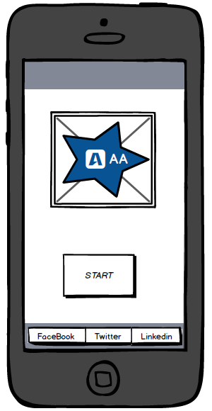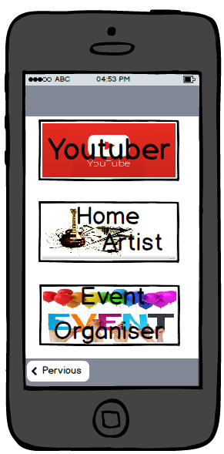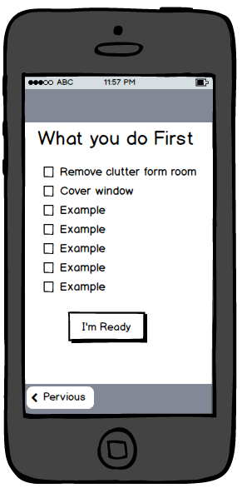

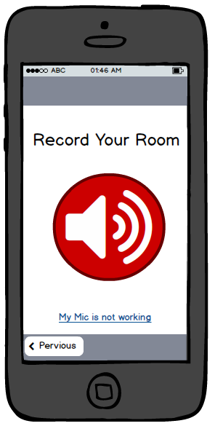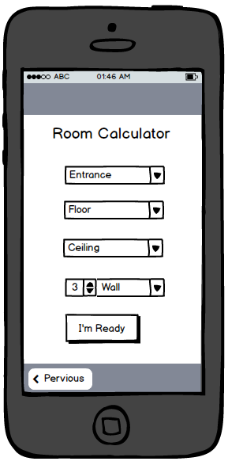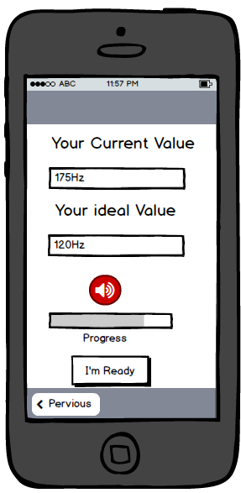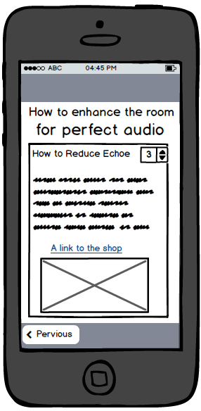

# System Architecture

Use a class diagram to outline the structure of the system. Explain briefly why you have chosen this architecture. You might want to use Visio or Rational Rose to create these.

# System Evolution

This section describes how the system could evolve over time.